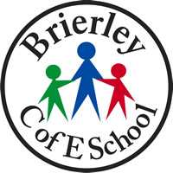

Children’s Privacy Notice and Data Protection

Our school collects and keeps personal information about you such as:-

- Your name
- Your address
- The date you were born
- Who looks after you and how we can get in touch with them
- Information about your health such as do you need and inhaler, are there any foods you can’t eat
- How often you come to school
- How well you are doing with your learning
- Any problems you have had in school
- If you move to a different school

We do this so we can:-

- Keep you safe
- Help you to stay healthy
- Help you to be happy
- Help you to learn well
- Tell your parents/ carers how well you are doing with your learning
- Tell others how well the school is doing

We keep this information very safe and follow special information protection rules and laws to make sure nobody can see or use your personal information unless we say it’s ok.

Sometimes we have to share this information with other people we know who help us to look after you.

We tell your parents/carers what personal information we have about you, how we keep it safe, what we use it for and who we share it with. Information is sometimes called data. Keeping personal information safe is called Data Protection

REMEMBER
Personal information should always be kept safe and not shared with people you don’t know

