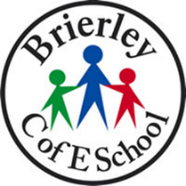

**BRIERLEY CE PRIMARY SCHOOL**

**SCIENCE CURRICULUM PATHWAY**

**Year 5**

**Year 4**

**Early Years**

**Year 6**



**Year**

**1**

**Year 3**



**Secondary School**

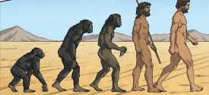

**Evolution**

**Key**

**Autumn 1st half term**

**Reproduction**

**Autumn 2nd half term**

**Spring 1st half term**

**Spring 2nd half term**

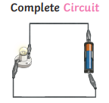

**Summer 1st half term**

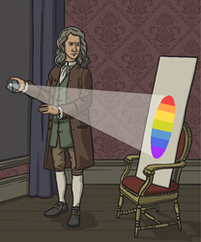

**The Human Body**

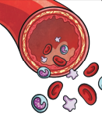

**Classification of Living Things**

**Summer 2nd half term**

**Electricity**

**Electricity**

**Light**

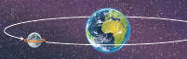

**Forces**

**Astronomy**

**Materials**

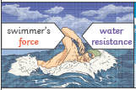

**Living Things and their Habitats**

**The Human Body**

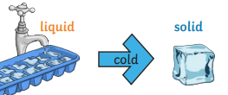

**Sound**

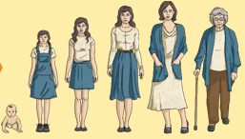

**Electricity**

**Ecology**

**States of Matter**

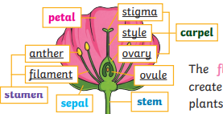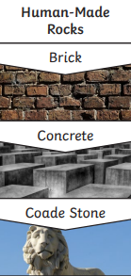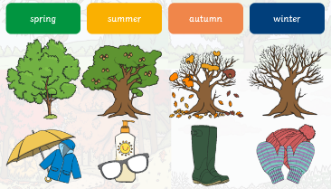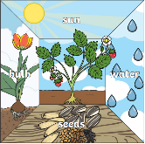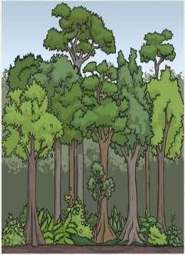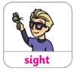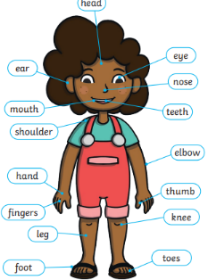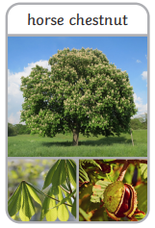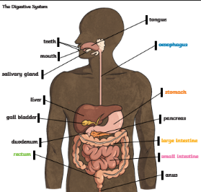

**Forces and Magnets**

**Human Body**

**Autumn**

**Woodland Animals**

**Body & Senses**

**Forces**

**Changing States of Matter**

**Earth and Space**

**Animals and their Needs**

**Animals Including Humans – My Body**

**Growing and Changing (Plants, Animals and Humans)**

**Cycles of Nature**

**Materials and Magnets**

**Astronomy**

**Changing States of Matter**

**Seasons and Weathers**

**Plants – Identifying Plants**

**Animals Including Humans**

**Electricity**

**Light**

**Plants**

**Rocks**

**The Human Body**

**Materials and Matter**

**Plants**

**Taking Care of the Earth**

**Year 2**

**Living Things & Their Environments**

**Classification of Plants and Animals**

**Summer**

**Sun Safety**