

**BRIERLEY CE PRIMARY SCHOOL**

**COMPUTING CURRICULUM PATHWAY**

**Year 5**

**Year 4**

**Early Years**

**Year 6**



**Year**

**1**

**Year 3**



**Secondary School**

**Creating Media: Stop Motion**

**Key**

**Creating Media: History of Computers**

**Data Handling: Big Data 2**

**Autumn 1st half term**

**Autumn 2nd half term**

**Spring 1st half term**

**Spring 2nd half term**

**Summer 1st half term**

**Programming: Intro into Python**

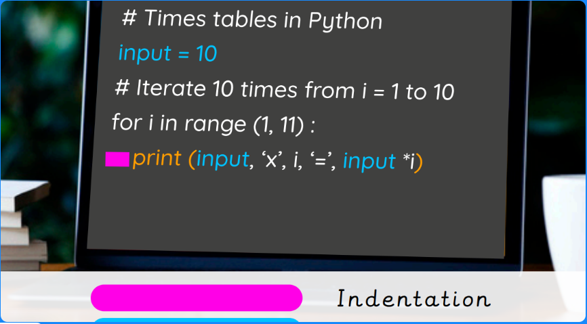

**Online Safety: Navigating the Internet in a safe and Respectful Way**

**Computing Systems and Networks: Bletchley Park**

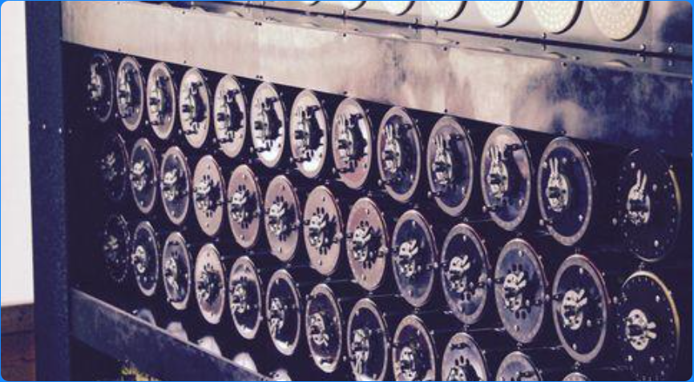

**Summer 2nd half term**

**Skills Showcase: Mars Rover 2**

**Data Handling:**

**Big Data 1**

**Data Handling: Mars Rover 1**

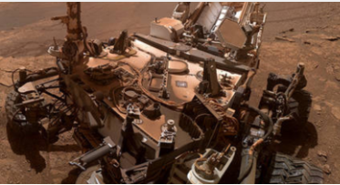

**Creating Media: Stop Motion Animation**



**Programming 1: Music**

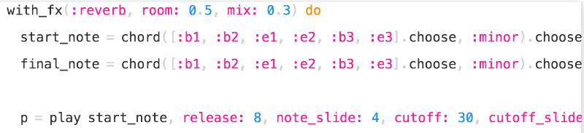

**Computing Systems and Networks: Search Engines**

**Online Safety: Potential Online Dangers**

**Further Coding with Scratch**



**Programming 2: Computational Thinking**

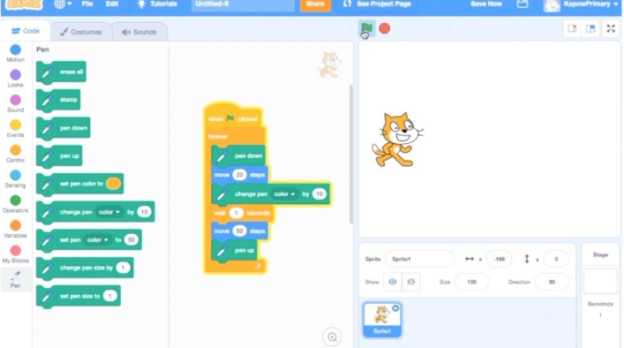

**Creating Media: Website Design**

Skills Showcase:

HTML

**Improving Mouse Skills: Logging in**

**Online Safety: Navigating the Internet**

**Data Handling: Comparison cards databases**

Creating Media: Video Trailers

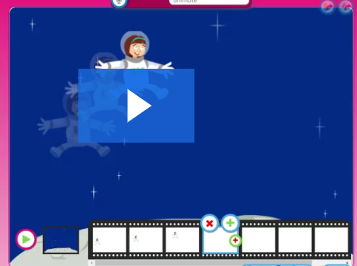

**Computing Systems and the Networks 2: Emailing**

**Programming: Scratch** 

**Computing Systems and Networks: Networks and the Internet**

**Online Safety:**

**Fake news, privacy settings etc.**

**Computing Systems and Networks: What is a computer?**

**Online Safety: What Happens when I Post Online?**

**Creating Media: Digital Imagery**



**Creating Media: Digital Imagery**



**Data Handling: Introduction into Data**



**Programming 2:**

**Bee- Bot**



**Online Safety: Using the Internet Safely**

**Data Handling: Introduction into Data**

**Programming 2: Bee-Bots**



**Programming: All about Instructions**



**Programming: Scratch Jnr**



**Computing Systems and Networks: Exploring hardware**

**Computing Systems and Networks: Using a Computer**

**Year 2**

**Computing Systems and Networks: Word Processing**

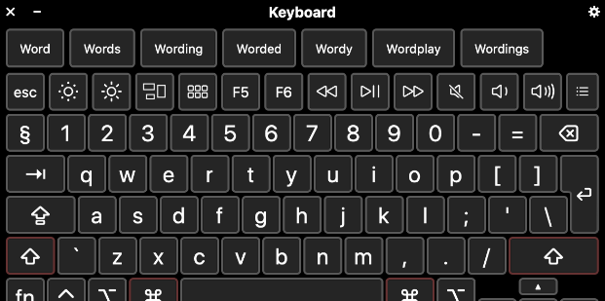

**Computing Systems and networks: Collaborative Learning**

**Programming: Alogorithms and debugging**